# Fake news detection using NLP

## Aim:

Fake news is a information that is false or mislanding. But it’s reported as news. In this project we’ll detect the fake news using the natural language processing. And we will seen the importance of detecting and battle against fake news.

## Abstract:

The phenomenon of Fake news is experiencing a rapid and growing progress with the evolution of the means of communication and Social media. Fake news detection is an emerging research area which is gaining big interest. It faces however some challenges due to the limited resources such as datasets and processing and analysing techniques. In this work, we propose a system for fake news detection that uses Term Frequency- Inverse Document Frequency(TF-IDF) of bag of words and n-grams as feature extraction technique, and Support Vector Machine(SVM) as a classifier. We propose also a dataset of fake and true news to train the proposed system. Obtained results show the efficiency of the system.

## NLP Techniques:



-Discuss the use of Natural Language Processing (NLP) in fake news detection.

-Explore techniques such as text classification, sentiment analysis and topic modeling.

# Data Collection and Pre-processing:

-Explain the process of collecting reliable news data for training and testing.

-Discuss the steps involved in preprocessing the data, including tokenization and removing stop words.



## Features Extraction:

-Highlight different machine learning algoriths suitable for fake news detection, such as logistic regression, random forests, or neural networks.

-Discuss the process of training and evaluating these models using labeled data.

## Evaluation Metrics:

-Explain the metrics used to evaluate the performance of the fake news detection model, such as accuracy, precision ,recall and F1 score.

## Limitations and Future Directions:

-Discuss the limitations of current fake news detection methods and potential areas for improvement.

-Highlight the importance of ongoing research in adapting to evolving fake news techniques.

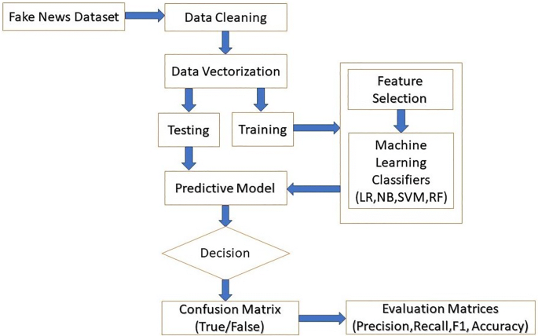

Advantages:

-Detecting and processing large volumes of data from various sources such as social media, online reviews and news reports.

-Providing valuable insights into brand performance.

-Detecting issues and addressing them to improve performance.

-Streamlining processes to make data analysis more efficient and effective.

-Providing insights that can be used for sentiment analysis, content classification and more.

Submitted by,

G.Sathya

G.Sakthi Priya

S.I.Syed ali Fathima

K.Porkalai selvi